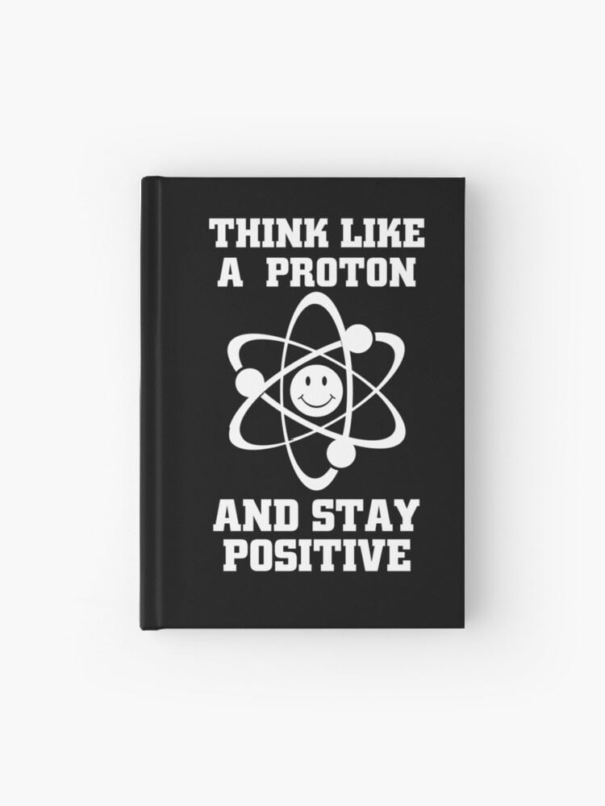**Advanced Chemistry**

**(7) Students**

**Teacher: Mr. O’Leary**

**Learning at Home**

Hello Advanced Chemistry Students!

Unfortunately we will not be in school for the remainder of the academic year. I know this is your senior year and I'm sorry that it will end this way. But this is what must be done to keep safe and look towards the future. The CLEP exam is probably not going to happen at this point, but I will keep you posted. The AP exam has been cancelled. You should by now have received your CLEP Chemistry Review Books. We will be working with these for the remainder of the academic year.

At this point (3/17) our district policy is as follows:

- You will be provided reinforcement work. I have included new concepts in the reviews and they are, of course, optional.

- Answer keys are provided for each assignment. (They are included in the review books)

- There will be no new grades entered and I will expect nothing back from you, as per school policy.

Please check my Advanced Chemistry website for videos, extra review and other curriculum related materials. Please email me if you have any questions related to our class. As always be safe and take care of yourselves.

- Mr. O'Leary

Attached are the assignments for the next weeks of Monday 5/11/202 – Friday 5/22/2020. They are all located in the CLEP Chemistry Test Prep book you should have received by now. Your textbook will be very helpful to review concepts and provide additional review.

**Week 3**

|  |  |  |
| --- | --- | --- |
| Date | Topic | Assignment |
| Monday 5/11 | **Electronic and Atomic Structure; Periodic Table** | Complete the odd questions on pages  63 – 78. The answer is located on page 81 and the detailed explanations (which are extremely helpful) are located in the sections beginning on page. 307. |
| Tuesday 5/12 | **Chemical Bonding** | Complete the odd questions on pages  81 – 93. The answer is located on page 94 and the detailed explanations (which are extremely helpful) are located in the sections beginning on page. 349. |
| Wednesday 5/13 | **Phases and Phase Equilibria**; This section contains some material we have covered as well as some material we have not covered. Give it a try and don’t stress about the concepts we have not yet covered. We will do our best when we return. | Complete the odd questions on pages  95 – 113. The answer is located on page 114 and the detailed explanations (which are extremely helpful) are located in the sections beginning on page. 375. |
| Thursday 5/14 | **Stoichiometry** | Complete the odd questions on pages  115 – 137. The answer is located on page 138 and the detailed explanations (which are extremely helpful) are located in the sections beginning on page. 411. |
| Friday 5/15 | **Thermochemistry;** This section contains some material we have covered as well as material we have not covered. Give it a try and don’t stress about the concepts we have not yet covered. We will do our best when we return. | Complete the odd questions on pages  139 – 155. The answer is located on page 156 and the detailed explanations (which are extremely helpful) are located in the sections beginning on page. 451. |

**Week 4**

|  |  |  |
| --- | --- | --- |
| Date | Topic | Assignment |
| Monday 5/18 | **Kinetics and Equilibrium**: This is mainly new stuff. We were about to get into kinetics and equilibrium just before school was closed. Give it a try and use your textbook or email me and I can guide you. Also check out tutorials on youtube. Some provide great assistance with the material. | Complete the odd questions on pages  157 – 181. The answer is located on page 182 and the detailed explanations (which are extremely helpful) are located in the sections beginning on page. 475. |
| Tuesday 5/19 | **Solution Chemistry**; This section contains plenty of stuff we have covered as well as some material we have not covered. Give it a try and don’t stress about the concepts we have not yet covered. We will do our best when we return. | Complete the odd questions on pages 183 – 201. The answer is located on page 202 and the detailed explanations (which are extremely helpful) are located in the sections beginning on page. 509. |
| Wednesday 5/20 | **Acids and Bases**; This section contains some material we have covered as well as material we have not covered. Give it a try and don’t stress about the concepts we have not yet covered. We will do our best when we return. | Complete the odd questions on pages  203 – 225. The answer is located on page 206 and the detailed explanations (which are extremely helpful) are located in the sections beginning on page. 535. |
| Thursday 5/21 | **Electrochemistry**; This is mainly new stuff. I teach electrochemistry along with voltaic cells, nuclear chemistry and organic chemistry in April. Give it a try and use your textbook or email me and I can guide you. Also check out tutorials on youtube. Some provide great assistance with the material. | Complete the odd questions on pages  227 – 243. The answer is located on page 244 and the detailed explanations (which are extremely helpful) are located in the sections beginning on page. 573. |
| Friday 5/22 | **Try a Diagnostic Test**! They are located in the front of the book with a detailed answer key in the back of the book. The quick answer key is located after each test. | Diagnostic Test #2 |